Milestone 1

Qatar University

Software Engineering L52
Aljohara Alsayaari 202308374
Maryam Alsulaiti 202208628
Shaikha Aldosari 202205096
Ghada Almarri 202205487
Dr Fatima Hamza

October 18, 2026

Declaration

We hereby certify that no part of this project or product has been copied from any other student’s work or from any other sources except where due acknowledgment is made in the project. No part of this project/product has been written/produced for us by any other persons.

Effort distribution of group members:

SID: __ 202308374_STUDENT NAME: _ Aljohara Alsayaari _Effort given___25_%
SID: __ 202208628_STUDENT NAME: _ Maryam Alsulaiti _Effort given___25__%
SID: __ 202205096_STUDENT NAME: _ Shaikha Aldosari_Effort given___25_%
SID: __ 202205487___STUDENT NAME: _ Ghada Almarri __Effort given___25__%

GitHub Repository URL:
GitHub Project URL:

Data Flow Diagram

Lvl 0
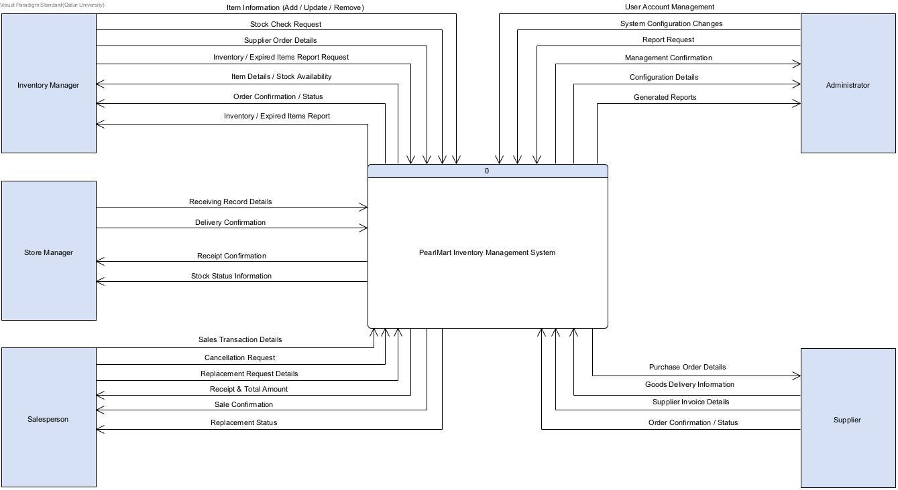

Lvl 1
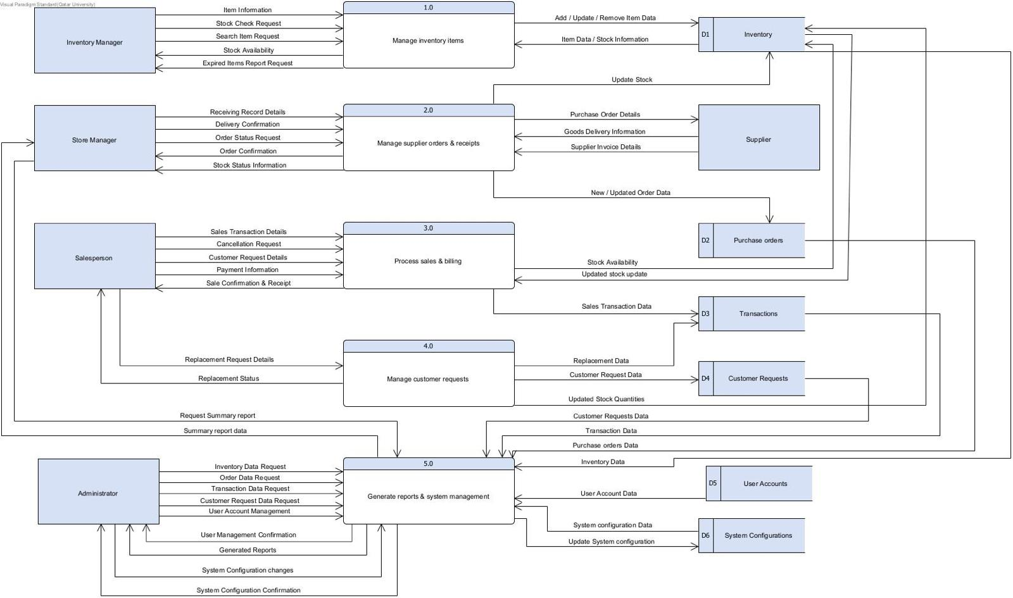

Lvl 2
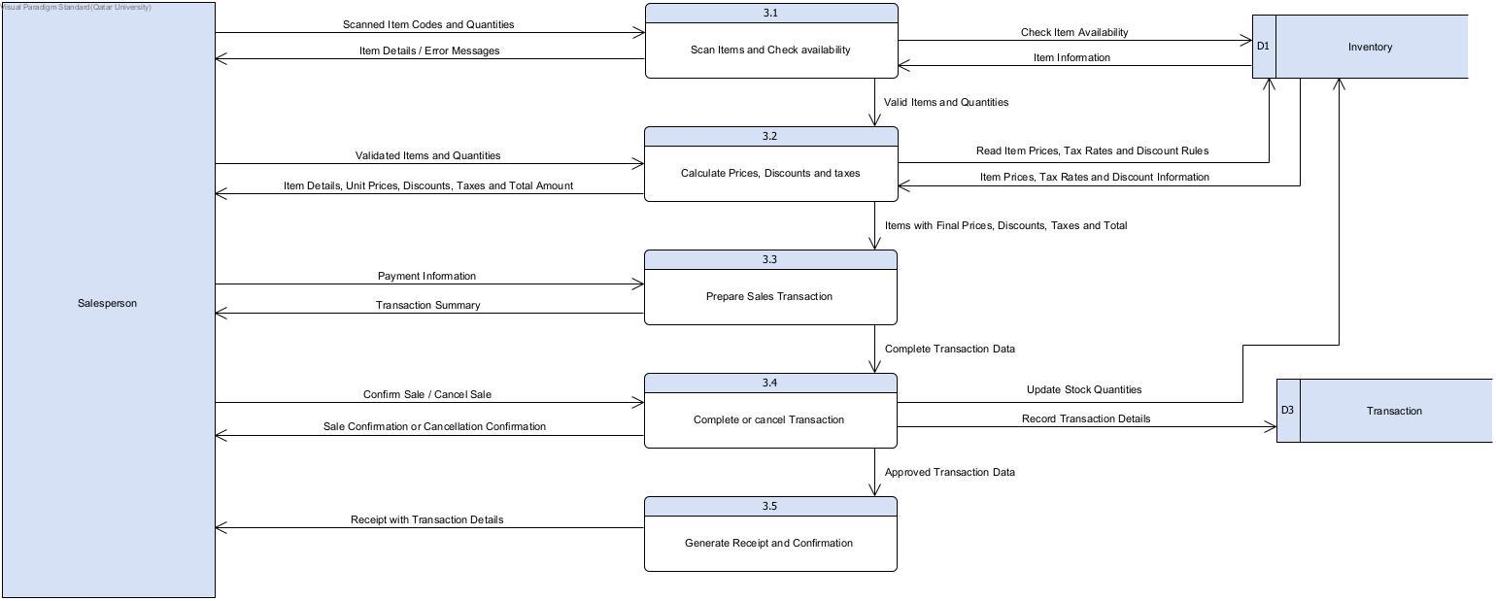

Use Case Diagram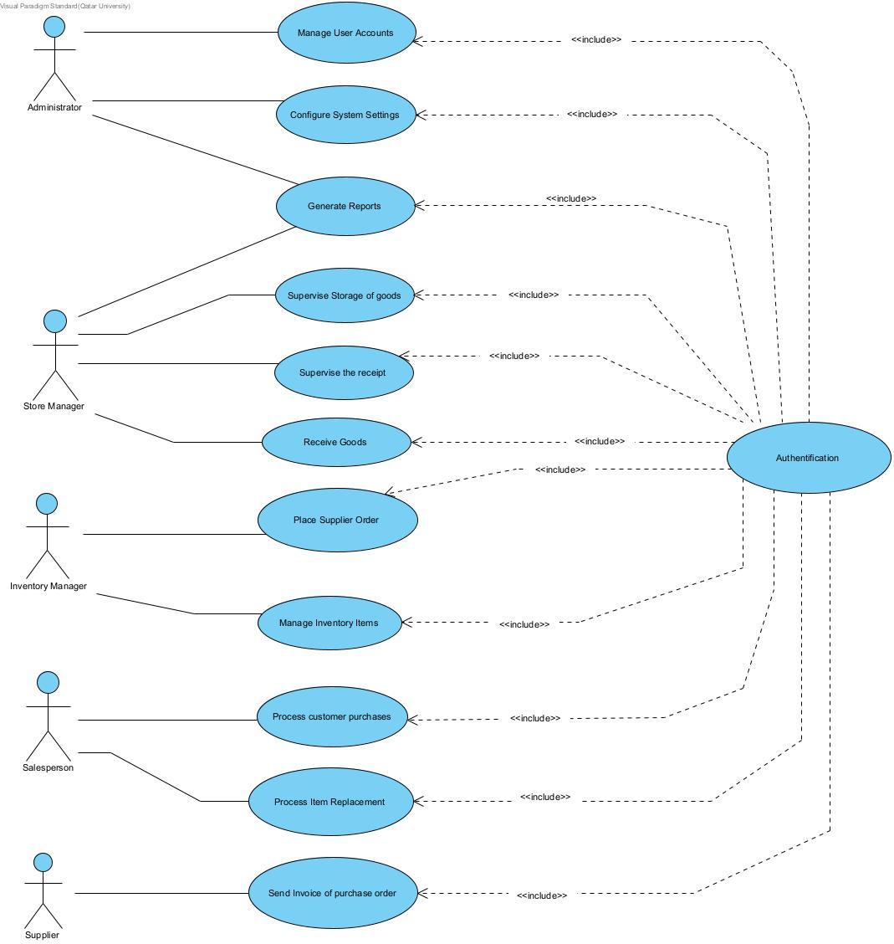

Use Case Specification

Use Case 1: Process Customer Purchase
Use case ID: | UC01 Process Customer Purchase
Brief description | This use case describes how PearlMart handles process customer purchase and records its outcome.
Primary actors | Salesperson
Trigger | The Salesperson initiates a new sale.
Preconditions | The Salesperson is authenticated; item and inventory records are accessible.
Postconditions | A completed sale is stored, quantities are reduced, and a receipt is issued.
Main Success Scenario

Actor Action | System Response
1. Salesperson starts a new sale. | 2. System opens an empty transaction.
3. Salesperson scans an item and enters quantity. | 4. System retrieves the item and checks stock (see 4.a and 4.b).
5. Salesperson adds any additional items. | 6. System displays the item list and calculates subtotal, applicable discounts, taxes and total.
7. Salesperson confirms the purchase and records payment. | 8. System validates the sale (see 8.a), records the transaction and deducts purchased quantities.
 | 9. System generates a receipt and confirms the sale.
Alternative flows:

4.a. Unknown barcode: the system reports the invalid barcode; the Salesperson retries step 3.

4.b. Insufficient stock: the system informs the Salesperson; the quantity is adjusted, the item is removed, or a separate customer request is recorded. Return to step 3 or 5.

8.a. Sale cancelled or validation fails: the system does not complete the sale or deduct inventory; it displays the cancellation/failure status.

Assumption: operational validations and status handling follow the proposed PearlMart design; confirm any rules not specified in the project brief.

Use Case 2: Place Supplier Order
Use case ID: | UC02 Place Supplier Order
Brief description | This use case describes how PearlMart handles place supplier order and records its outcome.
Primary actors | Inventory Manager; Supplier (supporting)
Trigger | The Inventory Manager selects Create Purchase Order.
Preconditions | The Inventory Manager is authenticated; suppliers and items are registered.
Postconditions | A purchase order is stored and sent to the selected supplier.
Main Success Scenario

Actor Action | System Response
1. Inventory Manager selects Create Purchase Order. | 2. System opens a purchase order form.
3. Inventory Manager selects a supplier and items. | 4. System displays supplier and item details.
5. Inventory Manager enters quantities and delivery details. | 6. System checks quantities and calculates order total (see 6.a).
7. Inventory Manager reviews and confirms the order. | 8. System assigns an order ID and saves the order.
 | 9. System transmits order details to the Supplier (see 9.a) and confirms submission.
Alternative flows:

6.a. Invalid quantity: the system requests a positive quantity; resume step 5.

9.a. Supplier transmission fails: the system retains the order as pending and informs the Inventory Manager; it does not report successful submission.

7.a. Order not confirmed: the Inventory Manager may edit or abandon the draft without sending it.
Assumption: operational validations and status handling follow the proposed PearlMart design; confirm any rules not specified in the project brief.

Use Case 3: Receive Goods
Use case ID: | UC03 Receive Goods
Brief description | This use case describes how PearlMart handles receive goods and records its outcome.
Primary actors | Store Manager; Supplier (supporting)
Trigger | A supplier delivery arrives and the Store Manager selects Receive Goods.
Preconditions | The Store Manager is authenticated; a corresponding purchase order exists.
Postconditions | An accepted goods receipt is recorded and inventory is increased by accepted quantities.
Main Success Scenario

Actor Action | System Response
1. Store Manager selects Receive Goods and enters an order ID. | 2. System retrieves the purchase order (see 2.a).
3. Store Manager checks delivered items and enters received quantities. | 4. System compares them with outstanding quantities (see 4.a and 4.b).
5. Store Manager confirms accepted goods. | 6. System records the receipt and increases stock for accepted quantities (see 6.a).
 | 7. System updates the order receipt status and displays confirmation.
Alternative flows:

2.a. Unknown order: the system reports the invalid ID; return to step 1.

4.a. Partial delivery: the system records only accepted quantities and sets the order to partially received.

4.b. Damaged or excess goods: the Store Manager records discrepancies; rejected goods are not added to inventory.

6.a. Inventory update failure: the receipt is not finalized; the system preserves consistency and reports the error.

Assumption: operational validations and status handling follow the proposed PearlMart design; confirm any rules not specified in the project brief.
Use Case 4: Process Item Replacement
Use case ID: | UC04 Process Item Replacement
Brief description | This use case describes how PearlMart handles process item replacement and records its outcome.
Primary actors | Salesperson; Store Manager (supporting)
Trigger | A customer asks to replace a previously purchased item.
Preconditions | The Salesperson is authenticated; an original sale exists; replacement rules are available.
Postconditions | An approved replacement is recorded, stock is adjusted and the request is marked completed.
Main Success Scenario

Actor Action | System Response
1. Salesperson enters the original sale/receipt ID. | 2. System retrieves the sale details (see 2.a).
3. Salesperson selects the item and records the replacement reason. | 4. System checks eligibility and creates a pending request (see 4.a).
5. Store Manager reviews and approves the request. | 6. System records approval (see 6.a).
7. Salesperson selects an available replacement item. | 8. System checks replacement stock (see 8.a).
9. Salesperson confirms the exchange. | 10. System records the replacement, adjusts stock according to returned-item condition, and marks the request completed (see 10.a).
 | 11. System displays replacement confirmation.
Alternative flows:

2.a. Original sale not found: the system requests a valid reference.

4.a. Item ineligible: the system rejects the request and displays the reason.

6.a. Approval denied: the system records rejection; no stock changes occur.

8.a. Replacement unavailable: the Salesperson selects another eligible item or leaves the request pending.

10.a. Stock update failure: the system does not mark the replacement completed and reports the error.

Assumption: operational validations and status handling follow the proposed PearlMart design; confirm any rules not specified in the project brief.

Design Class Diagram

